EXP NO: 1
Create a simple cloud software application and provide it as a service using any Cloud Service Provider to demonstrate Software as a Service (SaaS).
Aim
To develop a simple cloud-based Student Management System using Zoho Creator, demonstrating the Software as a Service (SaaS) cloud model for managing student information and automatically calculating the total academic fee.

Procedure
- Log in to Zoho Creator.
- Create a new application named Student Management System.
- Create a form and add the following fields:
  - Student ID
  - Student Name
  - Department
  - Academic Fee
  - Scholarship Amount
  - Total Fee
- Configure Total Fee as the output field.
- Add a Deluge script to calculate:
Total Fee = Academic Fee − Scholarship Amount
- Save the application.
- Run the application in the cloud.
- Enter the student details.
- The application automatically calculates and displays the total fee.
- Verify the output and save the record.

Implementation
if(input.Academic_Fee != null && input.Scholarship_Amount != null)
{
input.Total_Fee = input.Academic_Fee - input.Scholarship_Amount;
}

info "--------------------------------";
info "STUDENT MANAGEMENT SYSTEM";
info "--------------------------------";
info "Student ID : " + input.Student_ID;
info "Student Name : " + input.Student_Name;
info "Department : " + input.Department;
info "Academic Fee : Rs. " + input.Academic_Fee;
info "Scholarship : Rs. " + input.Scholarship_Amount;
info "Total Fee : Rs. " + input.Total_Fee;
info "Admission Status: Success";

Output
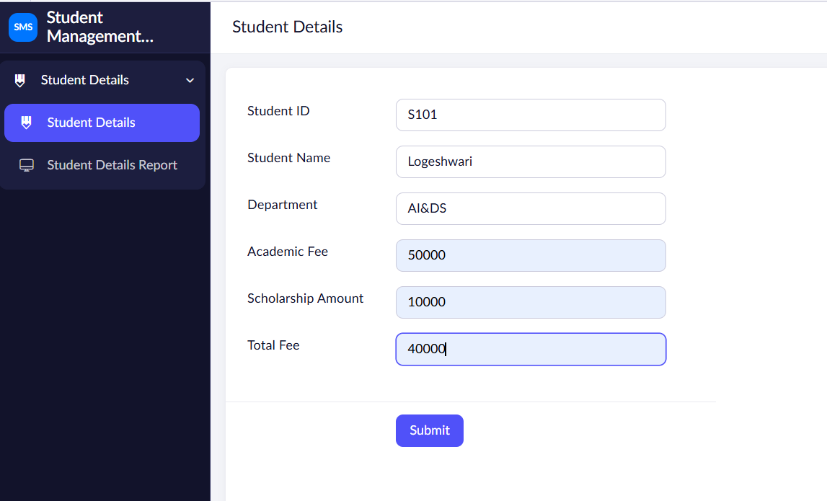

Result
The cloud-based Student Management System was successfully created using Zoho Creator (SaaS). The application accepts student details and automatically calculates the total academic fee after deducting the scholarship amount, demonstrating the Software as a Service (SaaS) cloud computing model.

